File name: neon_3_120s_notape_newtune3.fits

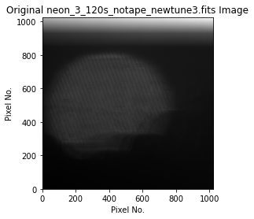

Cropped Interferogram

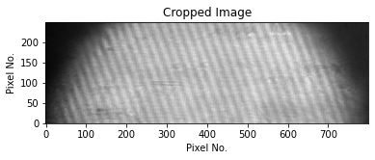

Median subtracted, average value subtracted, hanning window applied

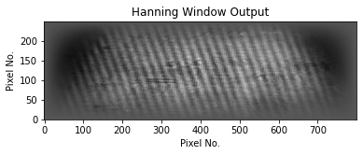

Transform

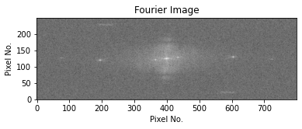

Row 120 slice cut + rows about/below

